FACULTY EVALUATION
Programme Name: Social Entrepreneurship Program (SEP) – SCALE MASTERCLASS Module 2 (ONLINE)– Uganda (1st June 2026 - 5th June 2026)
Session: Review (identify gaps/challenges)
your business plan from module 1|| Decide key issues for long-term sustainability|| Identify areas where support is needed
Faculty Name: Dr. James Onyoin
No. of Respondents: 4
No. of Participants: 10
Evaluation Parameter | (%) Individual Score | (%) Programme Average
Punctuality (Commencement and Completion of Sessions) | 75 | 83
How well do you understand the core concepts presented? | 90 | 90
Rate your confidence in applying the new skills learnt | 85 | 83
Degree of Faculty preparedness for the sessions | 90 | 94
Content and methodology of the program | 90 | 93
Quality of class and group discussions | 85 | 90
The information presented in the course is relevant to my work (ministry) | 90 | 94
Average scores | 86 | 90

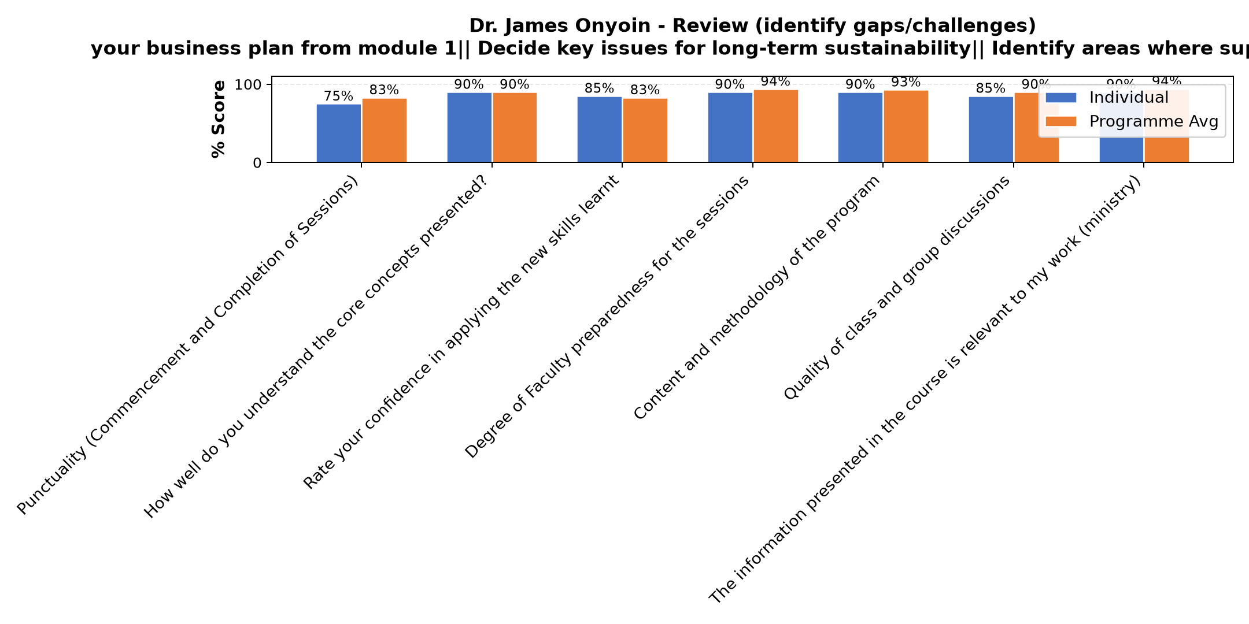

Comments & Feedback
- • Lack of enough time and data
- • Risk management
- • I will implement
SUBMITTED THROUGH:
SBS Evaluation Automation System

